International:  www.worldmarch.info  United States:  www.worldmarchusa.net  New York:  Tel: 212-313-8490  74-09 37th Ave., Suite 206  Jackson Heights NY 11372  info@worldmarchusa.net  International Coordination;  Mundo Sin Guerras  Rafael de la Rubia,  Director  rafael@marchamundial.org  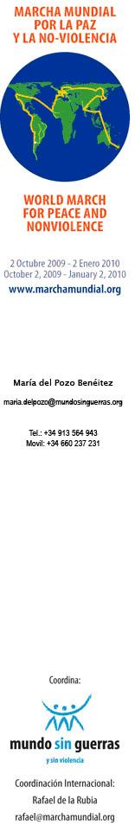 | Name  Address  March 2009  Dear Mr./Ms. _______:  I am writing to ask for your support for an international project of great scope and urgency: the first-ever “World March for Peace and Nonviolence.”  The March was first proposed by the international organization Mundo Sin Guerras (World Without Wars) in July 2008 and has since gathered the support of more than 800 organizations, associations, and educational institutions worldwide. The March is an effort to unite the voices of millions of people around the globe into a large-scale, multi-national call for nuclear disarmament, an end to war as a means of resolving conflict, and a universal rejections of all forms of violence.  Starting in New Zealand on October 2, 2009 – the International Day of Nonviolence – the March will travel through six continents and 100 countries over a period of three months, ending on January 2, 2010 in the heights of the Andes Mountains. During the march's 90-day journey, thousands of locally-developed initiatives are being organized in cities around the planet -- concerts, symposia, exhibits, cultural performances, social events, special publications, and acts of civil disobedience – all focused on bringing attention to the themes of the March and showcasing the enormous amount of knowledge, awareness and experience already developed in the areas of peace and nonviolence.  The March was initially to pass through 40 countries, but the response it has produced has been so great that it has doubled in scope. It is not surprising to see the great ideological, racial, generational, religious, and cultural diversity that is coming together in this common goal of Peace and Nonviolence – indeed, we have found it is the youth who are supporting the project most strongly. If this trend continues, the World March could become an event without precedent in history.  As of today, many international figures have endorsed the March, including the President of Chile Michelle Bachelet, Nobel laureates the Dalai Lama, Desmond Tutu, and Josè Saramago, Noam Chomsky, Viggo Mortensen, Yoko Ono, Pete Seeger, and several members of the European Parliament, including Vice-President Luisa Morgantini.  We are hoping that you would consider adding your name to this impressive list. Your endorsement would carry no further obligations, although if you would be interested in participating in any other ways we would be delighted. Your support alone will have impact and help us to continue reaching out to others about the march.  Thank you for your attention and consideration,  Sincerely,  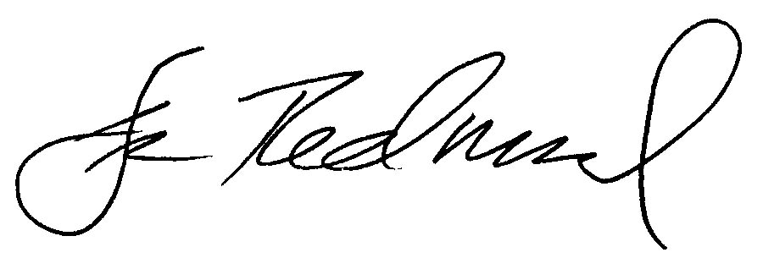  Dennis Redmond  National Coordinator/USA  World March for Peace and Nonviolence  info@worldmarchusa.net  www.worldmarch.info

